1. Open RedHat PAM Workbench ;

**URL** :  <http://172.30.0.79:8080/business-central/kie-wb.jsp>

**Username**  :   rhpamAdmin

**Password**    :   charles@123

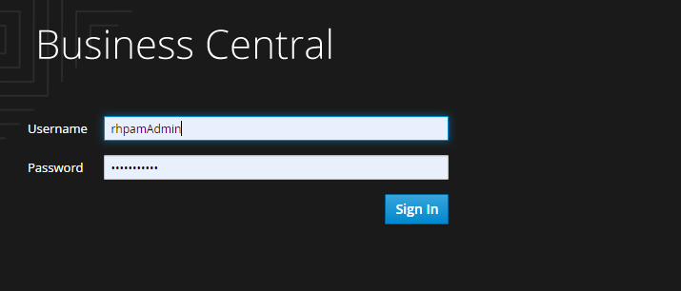

1. Navigate to Projects

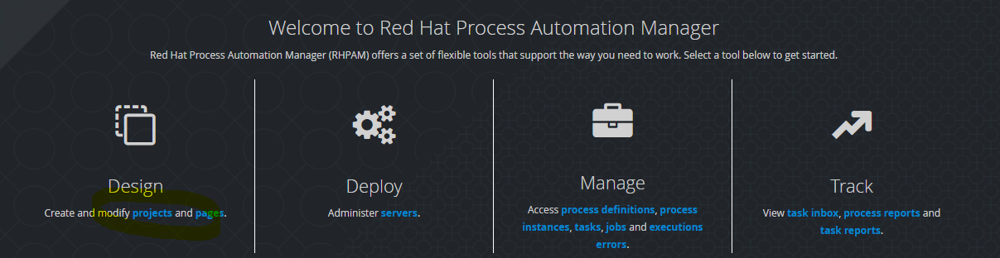

1. Click the PESTOS-Auto_Test (Project)

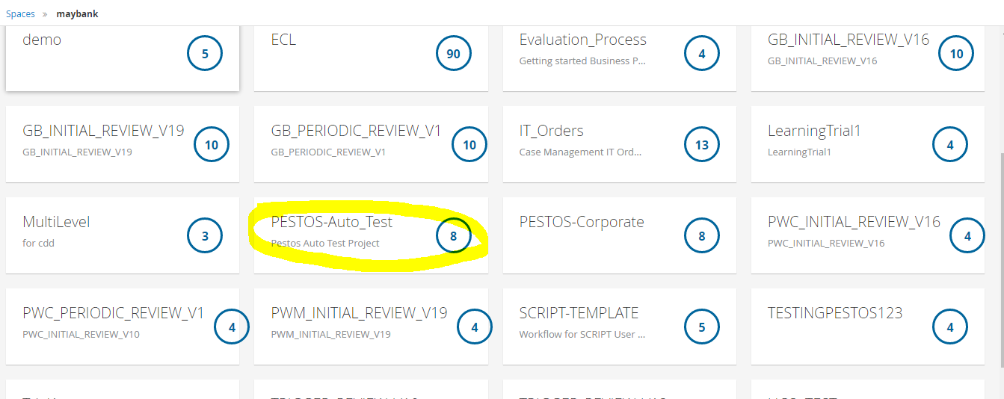

1. Inside the Project, Click Add Asset (located in the right corner)

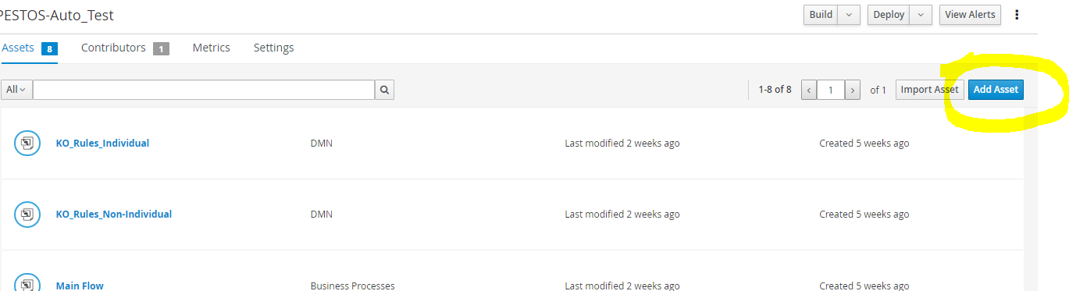

1. Inside the Asset Page, Click on DMN (for Rules creation), Business Process (for Workflow creation)

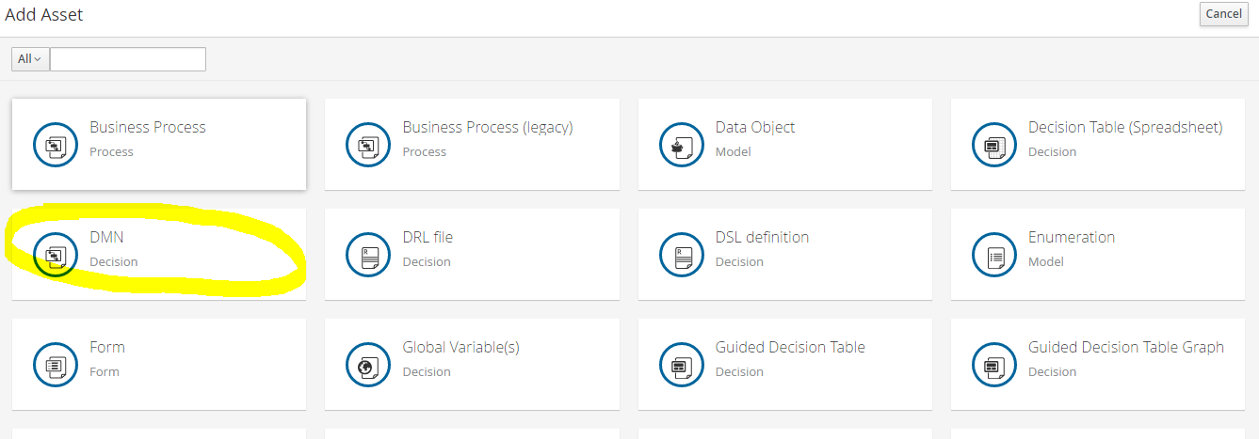

1. In the Create New DMN Screen, Enter the Name of the DMN (Business Rules) and select the package, then OK.

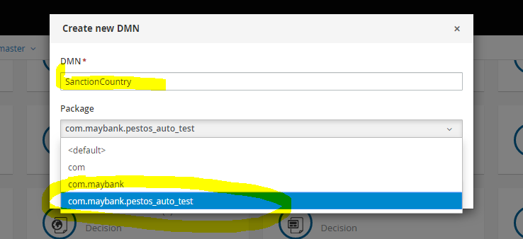

1. The DMN Canvas screen will now show.

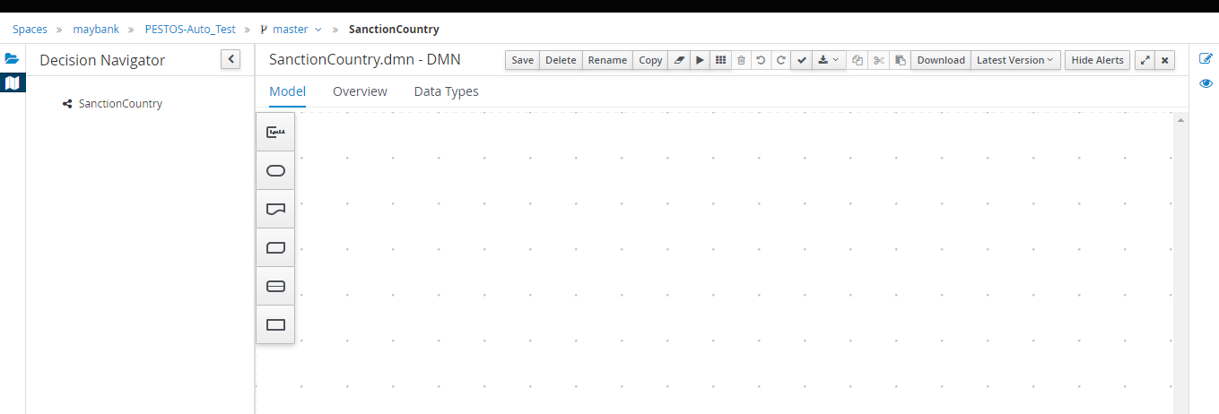

1. To Add an Input parameter, select the oval shape (DMN Input), then click on the canvas.

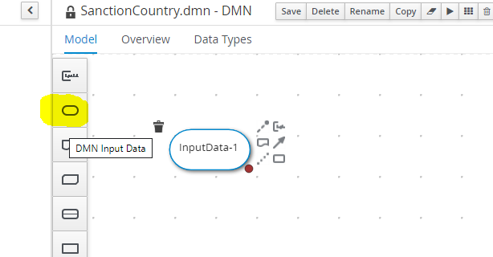

1. Double click the Input Data-1 to change the input parameter Name, after changing the Name, then Click the check icon.

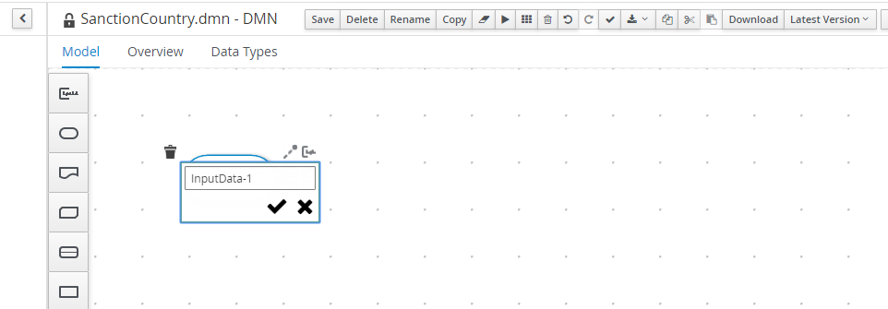

1. To change the data type of the input parameter, click the square with pen icon (located at the right top corner), the Diagram properties popup screen will show up. Then click the Output data type dropdown. 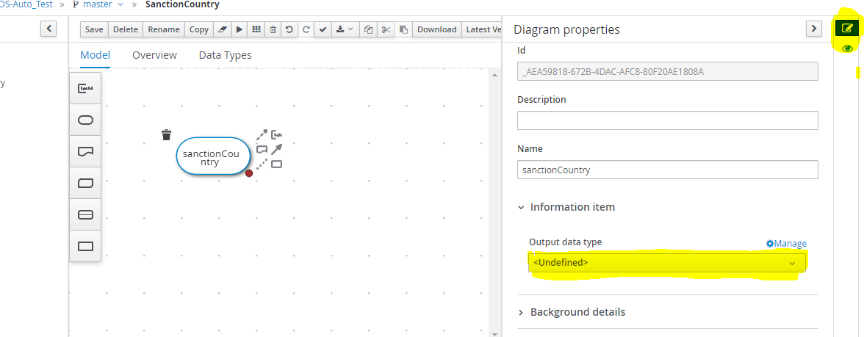
2. Select the data type from the selection. Then click again the square with pen icon to close the popup.

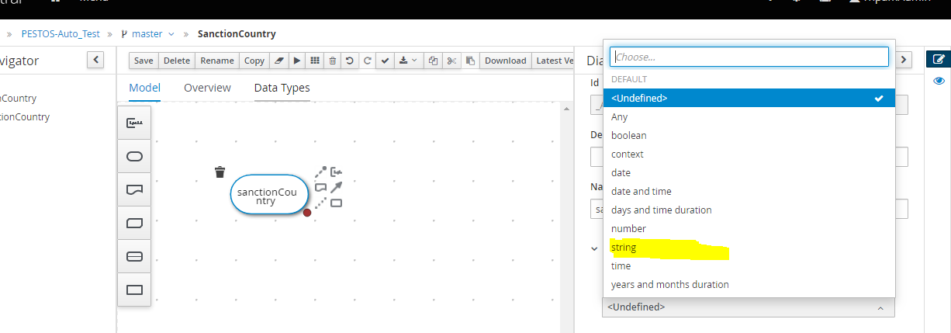

1. To Add decision, Hover in the input parameter component, then select the rectangle shape icon (Create DMN Decision),

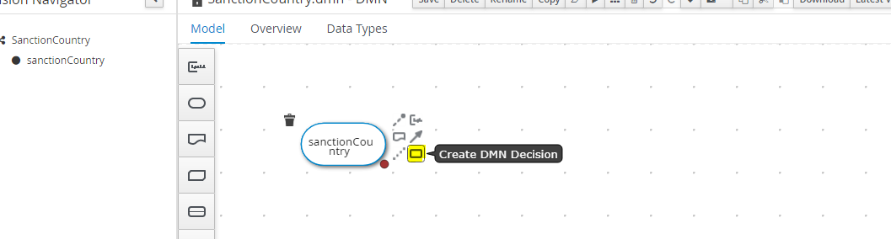

1. To define the rules inside the Decision, Hover in the Decision component and the click the square shape with pen icon (Edit).

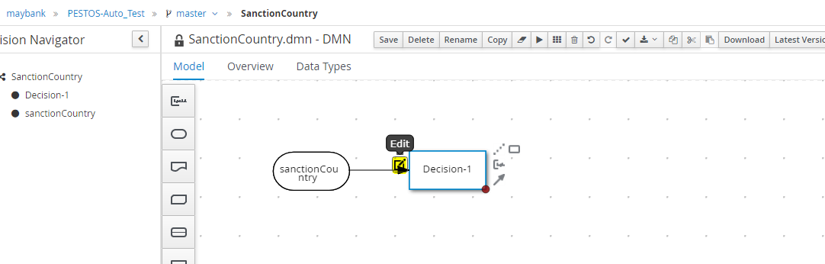

1. From the Edit Decision screen, Click the Select Expression and choose Decision Table from the options.

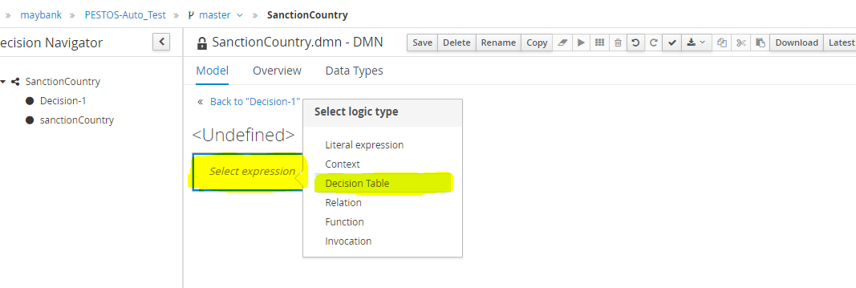

1. From the Table Decision screen



1. From the Table Decision click on the left top box with “Q”, from the selection, you can choose; Unique – if you know the combination is unique

First – the system will evaluate the rules from top to botton, once the rule (each row corresponds to a rule) is hit then it will not evaluate the rest of the rules. (normally we choose this)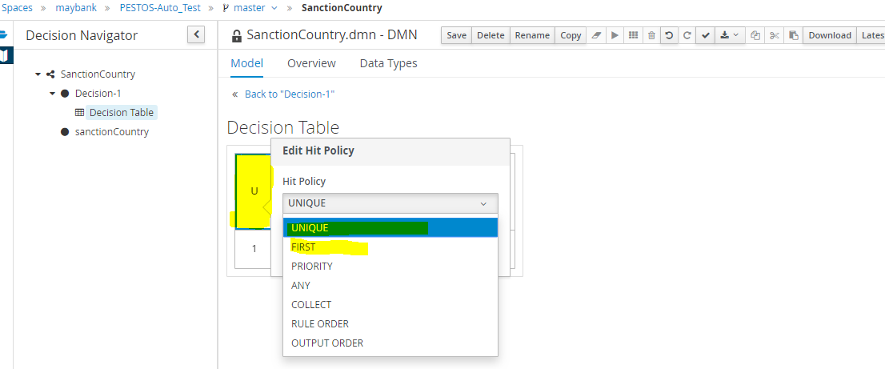

1. After selecting the Hit Policy, click anywhere to close.
2. By default there will be 1 rule (row)

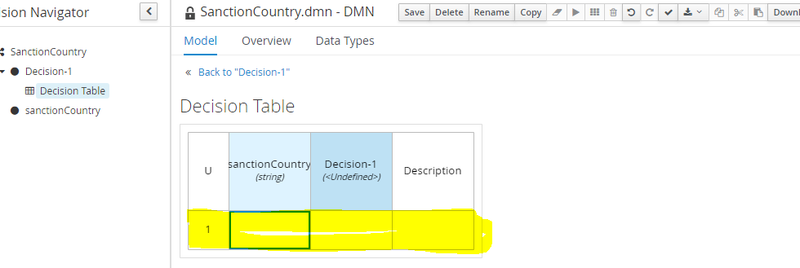

1. To change the name of the decision, as well as change the Data type of the Decision. Double click the Decision-1, then change the Name and Data Type. Then click anywhere to close.

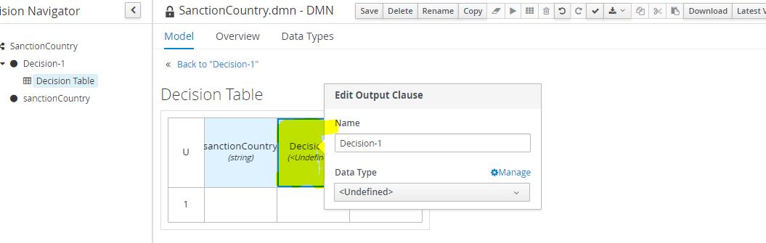

1. To add rules and decision, Double click the cells/column under the input and decision and add your rules and decision.

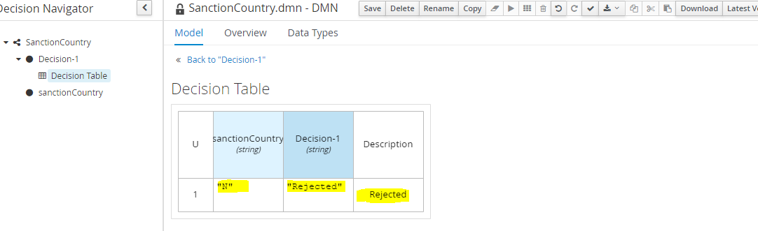

Note: To Define a String rule, it should be embedded in double quote. i.e “Y” or “N”

1. To add another rule, right click anywhere in the first rule and select insert rule below/ above. To delete the rule, you can also click on the rule then right click then Delete rule.

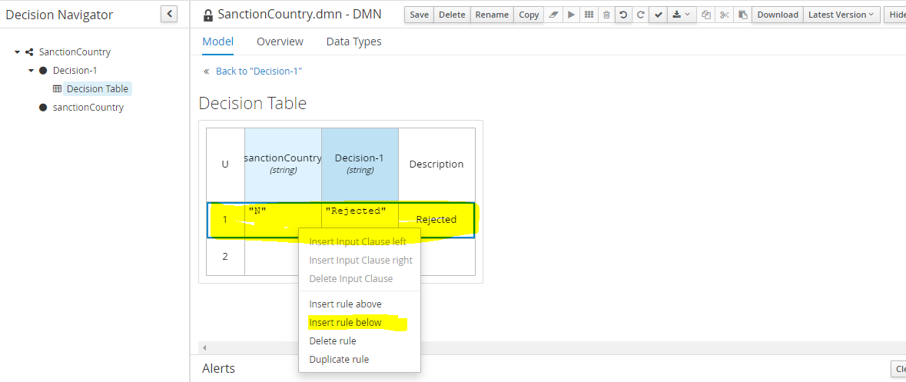

1. To add another decision, right click anywhere in the rules (rows) and select Insert Output Clause left/right.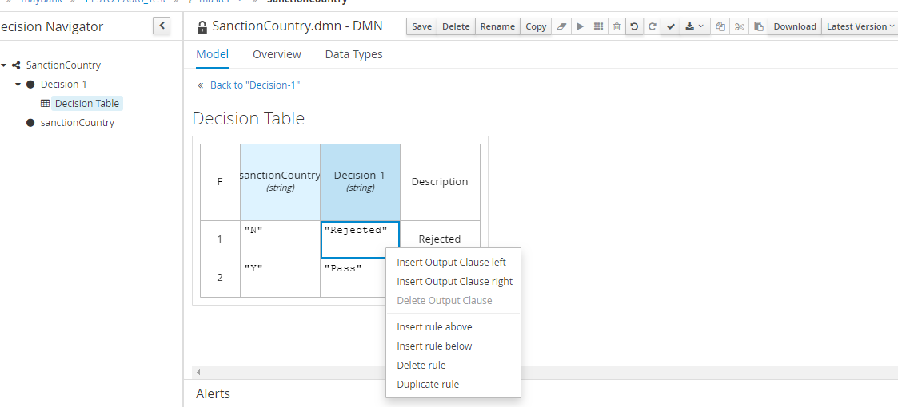
2. Then change the Name and Data Type. Then click anywhere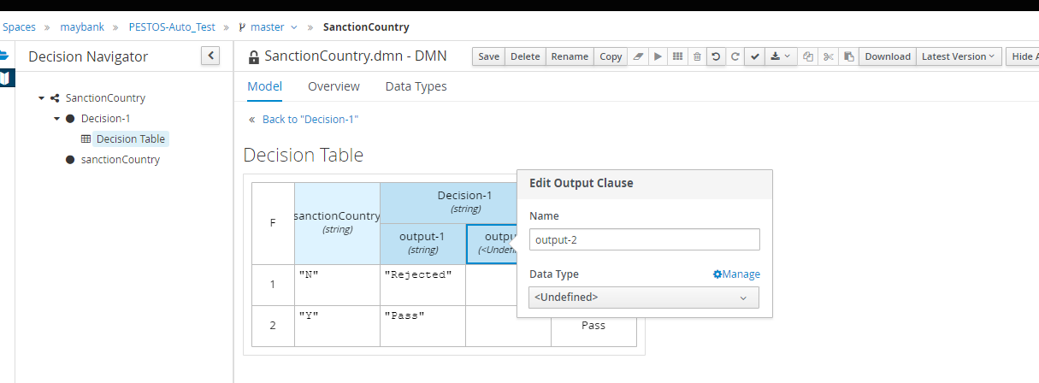
3. After defining all the rules and decision, Click the Back to Decision-1.

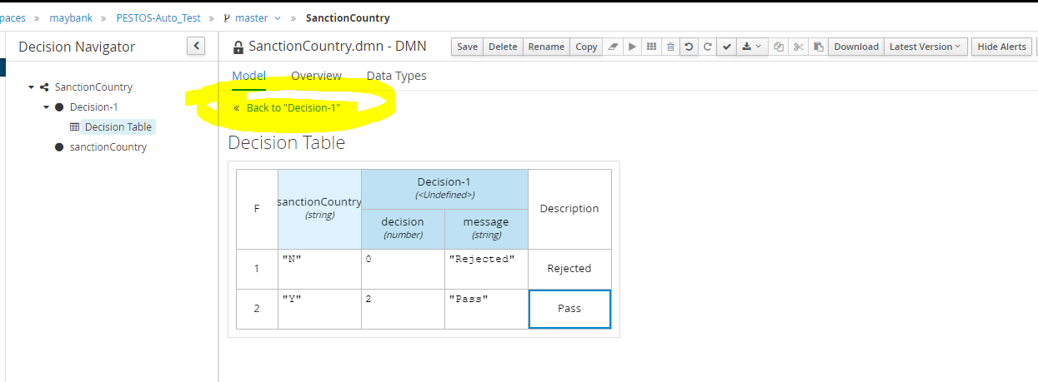

1. Click the Decision-1 box and then click again the square with pen icon.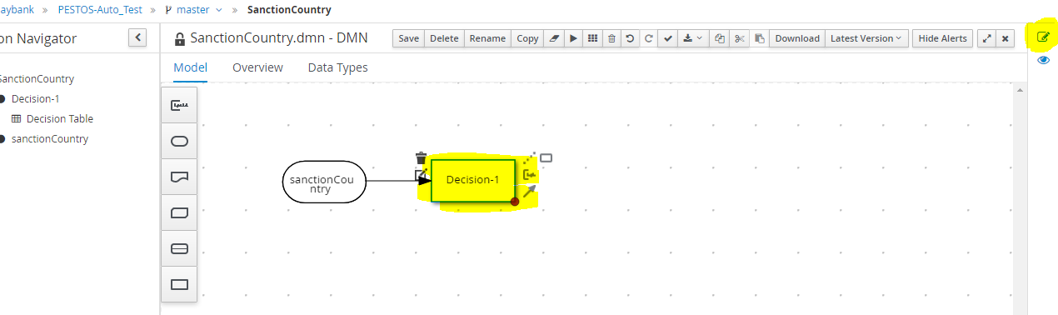
2. From Diagram properties screen, Change the Name, then click the Manage with gear icon located in the right bottom area. Data Types Tab screen will show, click the Add (+) icon.

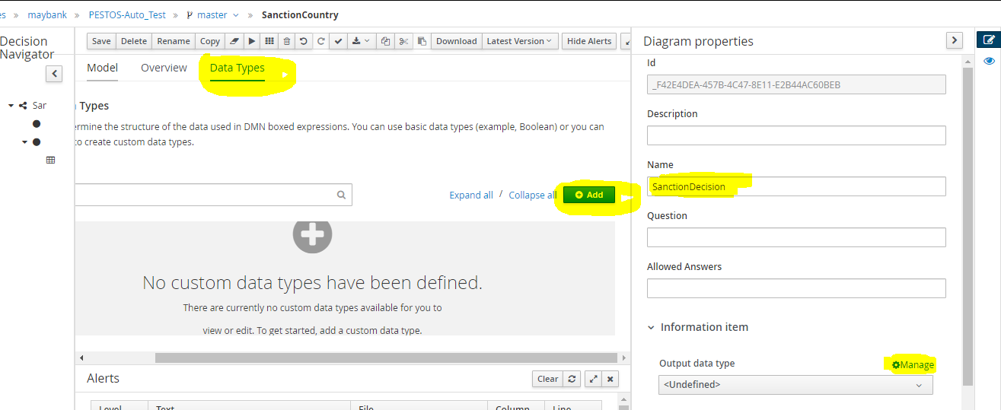

1. Change the Name, then select Structure as a type. Then click Save.

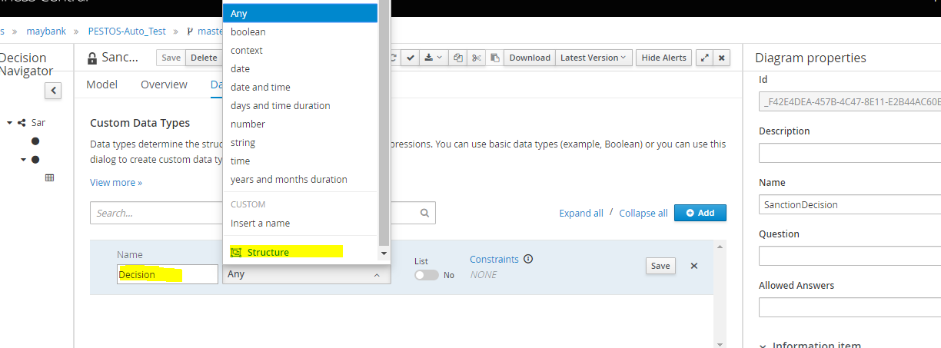

1. Click the 3 dots, Then select Insert nested field

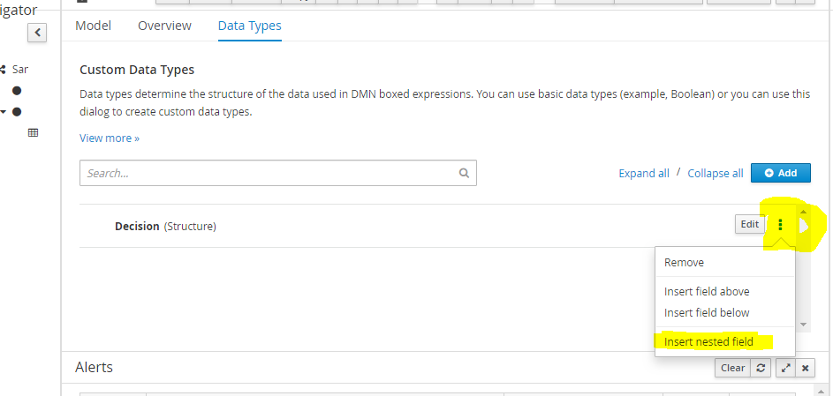

1. Change the Name and Type and Save, add 2 nested field,
2. name:decision, type:number
3. name:message, type:string

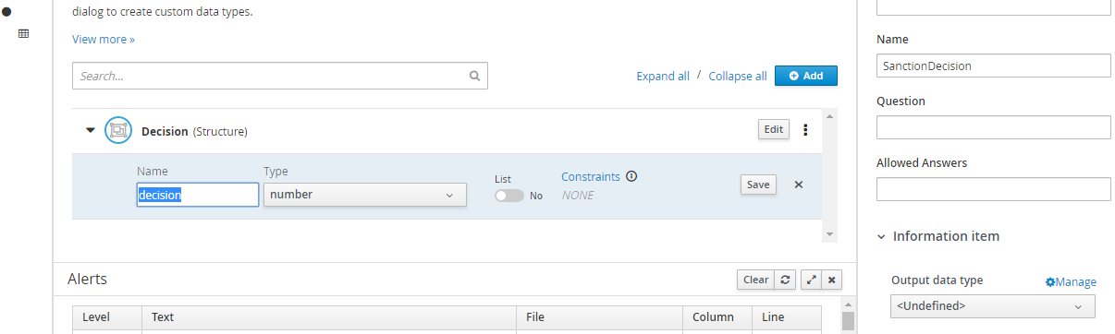

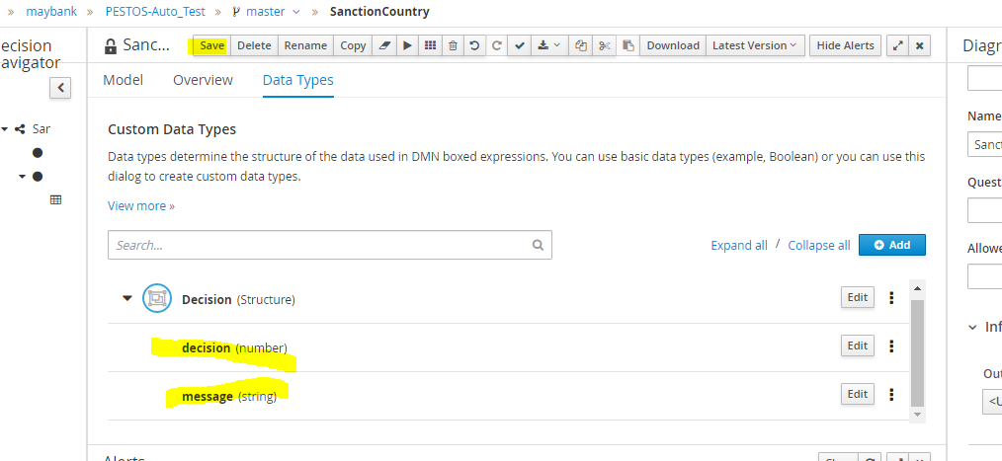

1. After saving, Click on Model, then Select the Model (sanctionDecision), then change the Type as Decision (usually the Complex Type is in the last option).

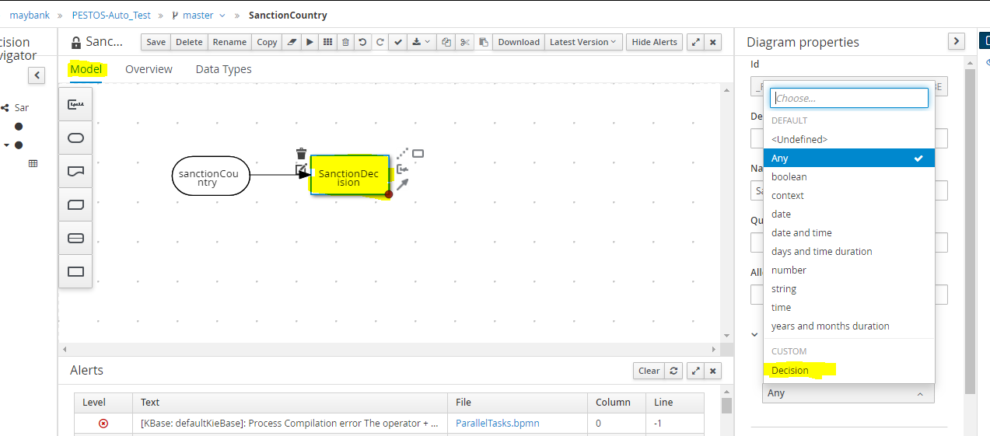

1. Save. DMN Completed. Make sure no error in the Alert section or else, you can build and deploy the Package. (Below is the sample error, the error is error in Workflow also created in this package)

